**Visualizations of Regression Analysis and Choropleth**

The scatter plot on the left side shows a linear positive relationship between average life expectancy and average CO2 consumption. However, the R-squared value is too low, and the p-value is above 10%. But when we used a power function in the scatter plot on the right side, we saw that the squared value went up to 0.23 and the p-value is statistically significant, so we conclude that the model on the right better fits the data.

The choropleth on the right side shows China United States and India being the highest CO2 emission-producing countries which is also represented on the graph on the left side which shows China United States and India towards the right side of the graph.

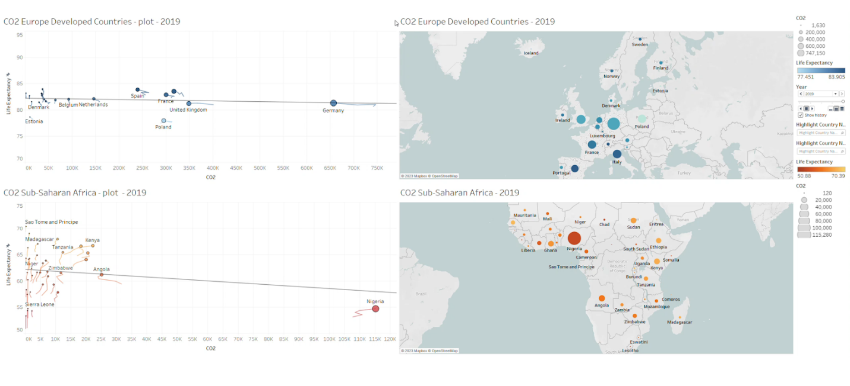

Here, we want to focus on sub-Saharan African countries and make a comparison between these countries and developed Europe. To make this comparison we have made two Time series scatter plots for each of these regions.

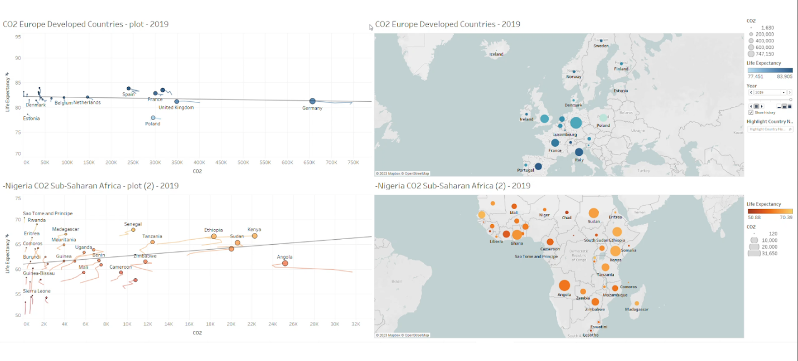

We have decided to exclude Nigeria because this country is exceptional (outlier) in the sub-Saharan region in terms of natural gas and oil Manufacturing. Once we exclude Nigeria, we see that there is a positive linear relationship between life expectancy and CO2 emissions in the sub-Saharan Africa region. That's because most of these countries are developing countries and more factories are opened every year making more CO2 emissions. Also, more factories mean more job opportunities, which improves life expectancy. In the developed Europe scatter plot we see giant manufacturing countries like Germany, Great Britain, and France reducing their carbon footprint which we think is because of two reasons. The first reason is climate change and the issue of pollution, and the second reason is the Russia and Ukraine war of 2016 which led to Russia's Natural Gas supply being caught off to Europe.